Team Kinetic Robotics

Technical Report

**Executive Summary**

Due to the process of school review and funding problems of our team, the ICRA official robot has not been obtained so far, so that the infantry from the RoboMaster 2019 competition was informed. If the referee system configuration is a necessary condition for technical report review, then it can finish reading in advance, we specifically apologise about this.

This report can be divided into two parts: Hardware and Software.

The Hardware part introduces three important firmware in the ICRA challenge, Mechanical Structure, Sensor, and Computing Device. It mainly describes the improved description based on the robot, the sensor layout, the reason for selection and its parameters.

The Software part shows that our strategy of Positioning, Motion Planning, Detection, Fire Automation, Automatic Supply, and Intelligent Decision. It mainly describes the algorithm we used, the performance of the algorithm, the problems encountered during our preparation, and proposes a possible improvement.

Contents

Pre-content 0

**1. Hardware** 0

**1.1 Mechanical Structure** 0

**1.1.1 Chassis** 0

**1.1.2 Gimbal** 1

**1.2 Sensor Module** 1

**1.2.1 Camera** 1

**1.2.2 LiDAR** 2

**1.2.3 Ultrasonic sensor** 3

**1.3 Computing Device** 3

**2. Software** 4

**2.1 Localization** 4

**2.2 Motion Planning** 4

**2.3 Automatic Detection** 5

**2.4 Fire Automation** 5

**2.5 Automatic Supply** 5

**2.6 Intelligent Decision** 5

# **1. Hardware**

## **1.1 Mechanical Structure**

The former ICRA robot mechanical structure is roughly unchanged, and we have equipped a LiDAR base and a camera base. Moreover, it intends to improve the size of the magazine in the future, increase the area of ​​the magazine, to improve the fault tolerance of automatic replenishment.

The LiDAR base is mounted in front of the battery holder, from the robot coordinate centre (x, y, z, r, p, y). The camera base is mounted on the upper part of the PTZ axis motor, away from the robot coordinate centre.

Figure 1，figure 2

Todo：

底盘主控板放置于底盘右侧。

Tx2放置于底盘右侧，由底盘主控板分电进行供电。

Usb hub放置于底盘右侧。

Figure 3

## **1.2 Sensor Module**

### **1.2.1 Single Gyro**

Since the RoboMaster official infantry is currently used for testing, the gyroscope module is missing. Through the network search, a high-precision single-axis gyroscope often requires several thousand RMB. Due to the shortage of funds, we prefer cost-effective single gyro. After a long time for Searching, finding, and finally locked an ADI high-precision single-axis gyroscope, which sells for less than a thousand dollars, but the performance is said to be less than 2 degrees in 10 minutes.

Through the actual measurement, the information obtained by ROS /odom topic can be counted, ... minutes... the degree of change, the accuracy is enough to meet the requirements of the challenge.

Figure 4

### **1.2.2 Camera**

Based on our previous experiences, it is highly important to choose a camera that can reduce motion blur. In addition, the parameter adjustment is also one of the necessary functions, which represents the convenience. Compare and contrast with previous experience, monocular camera, binocular camera these two cameras are included in our consideration.

For monocular camera,

Todo : 工业摄像头， 参数, 算法设置多少，强调后面算法提到

For binocular camera, the two most important factors we consider are depth sensing and motion tracking. The binocular camera can easily detect the distance between the enemy robot, and then shoot. As a matter of fact, we consider using binocular camera Intel RealSense after the basic implementation of monocular camera:

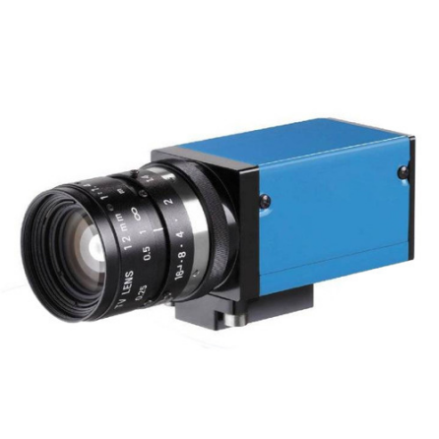

Intel RealSense D415 Monocular Camera

Figure 5 (detection img)， figure 6 (depth img)

As mentioned above we finally chose a camera that supports USB3.0, parameters adjustment and high frame rate for motion blur reduction. The resolution of the camera is not that satisfactory, with only 640x360 resolution rate, but the competition does not require the resolution rate that much. It is quite enough to get image features such as amour light bar on this resolution rate. In short, the camera we have chosen is quite enough for the competition.

### **1.2.3 LiDAR**

LiDAR is a critical device for localization and navigation. Since the LiDAR works like shine a small light at a surface and measure the time it takes to return to its source, Therefore the adaptive scanning frequency and range sample frequency would be the high priorities for choosing a LiDAR.

The LiDAR we are going to use is the G4 LiDAR which developed by ydLiDAR co., with range sample frequency about 9000hz, scanning range around 16m and maximum 12Hz adaptive scanning frequency. The reason why we are choosing this LiDAR is that it has the highest adaptive scanning frequency and range sample frequency among the same type of product, and the price is also quite reasonable.

Todo：放扫描图，最远距离。。。figure 7

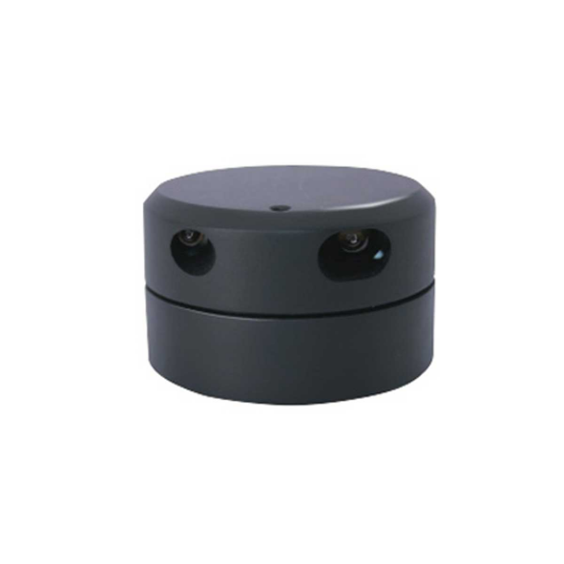

LiDAR

## **1.3 Computing Device**

We have two options for computing equipment. The first one is Nvidia Jetson TX2 and the second one is IPC. For a few reasons, we chose the first one:

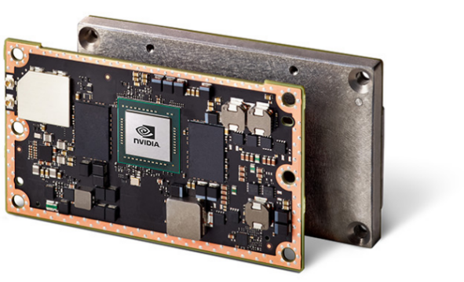First, Jetson TX2 is a tiny little board built around Nvidia Pascal-family GPU with 256 CUDA cores which means faster speed on matrix multiplication. The CPU complex consists of a Quad-core A57 ARM processor connected to a dual core Denver processor, way slower than the I7, but it is ok to use.

|  |  |
| --- | --- |
|  | Nvidia Jetson TX2 |
| GPU | Nvidia Pascal, 256 CUDA cores |
| CPU | HMP Dual Denver 2/2 MB L2 |
|  | Quad ARM A57.2 MB L2 |
| Memory | 8 GB 128bit LPDDR4 59.7GB/s |
| Data Storage | 32GB eMMC |

Jetson TX2

Second, the IPC we have is without the GPU processing core (GPU...).

Third, the IPC is large in size and high in power consumption. It requires external power supply equipment, but there is no such a space left inside of the robot. …

# **2. Software**

## **2.1 Localization**

After a period of research and exploration, we decided to use the AMCL algorithm to locate. AMCL is a probabilistic localisation system for a robot moving in 2D. ACML算法是什么…

2、figure8初始定位精度怎么样，刷新时间？figure9，10，11随机定位精度怎么样，刷新时间？对角线来回1次精度怎么样？3次？5次？测量离墙壁x，y距离

3、总结

## **2.2 Motion Planning**

1、采用避障传感器为雷达，过滤多少度的数据。Figure 12， 13

2、全局路径规划采用A*，规划频率。Figure 13

3、局部路径规划采用TEB，Figure 14，规划频率，最大运动速度，避障能力（见视频）

## **2.3 Detection**

Detection is mainly reflected in the Armor Detection in the challenge.

1、识别装甲板，描述算法figure 15～20

2、获取敌人大概方位和距离

Map来获取敌人，算法：

在AMCL里面，将scan points里面与障碍点匹配（符合一定范围内）的point 设置为false，剩下的设置为true，设置两个KNN点，邻近两个点集，由于在ICRA的赛场上机器人显得十分突兀，且和墙壁有一段距离，故knn迭代一次两次即可确定机器人的粗略位置（迭代多次反而不好），同时即可发现敌人方便决策，也可运用于自动打击的距离误差补偿上。

## **2.4 Fire Automation**

1、

2、在自己的机器人上测试官方的demo时发现两种情况，

## **2.5 Automatic Supply**

1、雷达ACML定位，补给，发送指令，描述误差，精度。

The overall thinking procedure is probably as follows: When the magazine wheel is operated, the limit switch of the barrel does not find that the bullet has passed for 3 seconds, and it is judged by itself that there is no bullet in the magazine, and then according to the approximate position information of the enemy, it is judged whether or not to replenish.

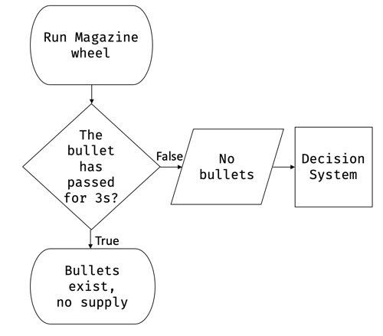

## **2.6 Intelligent Decision**

1、pygame，gym（A3C，说一下SC2，再放图 （说一下单机决策，因为没有两台机

2、决策树